CLE Team– Good News Stories

April - May 2015 edition

Kurdiji Law & Justice Group meet with Magistrate Sue Oliver in Lajamanu

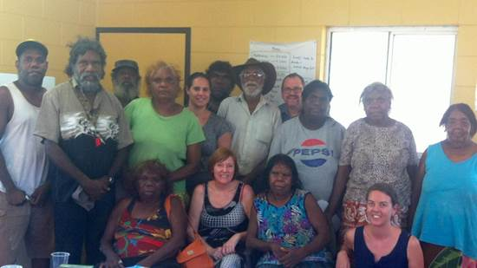

In the March Lajamanu trip, the CLE team facilitated a successful meeting between the Kurdiji Law & Justice group and Magistrate Sue Oliver.

Senior Kurdiji elder Jerry Jangala Patrick welcomed Ms Oliver with an overview and introduction to Warlpiri law. The group discussed youth offending and sentencing/bail options which would allow young offenders to stay in community. The group also discussed the possibility of the Kurdiji conducting offender conferences with offender and family members before plea dates.

Ms Oliver expressed her support for these ideas and gave the group an overview of sentencing principles, the criminal justice system and mandatory sentencing. Ms Oliver provided a clear overview of the court process in relation to DVOS, which included conducting a separate meeting with Kurdiji women who were able to speak directly to the Magistrate about domestic violence in their community. The meeting was such a success; Ms Oliver has requested another meeting with the Kurdiji next court sitting in May.

CLE Short Film project well and truly in production

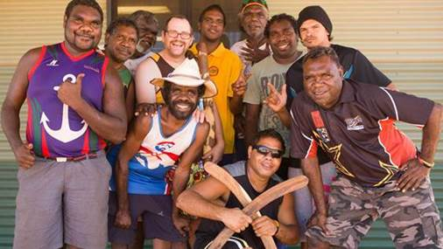

“Community Law Stories”, the CLE Short Film project, is well and truly in production. Independent filmmaker Mayeta Clark has accompanied the CLE team to three communities so far and shot two legal education films on Facebook fighting/cyberbullying in Lajamanu and one on child protection in Wurrumiyanga.

The project kicked off during the CLE March trip to Lajamanu, with one of the films starring our very own Will Crawford acting in Warlpiri. The CLE team conducted four script writing workshops with community, including inviting Jerry Jangala Patrick and Wanta Steve Junpajinpaa to be key cultural advisors for the men’s film. Involving elders in the script writing process was invaluable as it enabled Warlpiri traditional dispute resolution principles to be incorporated into the storyline and script, while ensuring that the script was culturally informed and safe.

The final stage of Community Law Stories commenced filming in Ramingining 5 May 2015, where we hope 3-4 films will be produced with the generous assistance of ALPA’s RJCP team. The CLE team will be conducting legal education/script writing sessions with RJCP participants. The proposed topics to be covered in these communities include interacting well with police/right to silence, bail/consequences of missing court, criminal law/sentencing process, health complaints and housing. Filming will conclude on 7 June and we hope to be able to release the edited films at the end of June.

The CLE team would like to thank both the civil and criminal teams for their consultation and advice regarding the films’ key legal messages.

Gunbalanya Cultural Community Resource launched in Gunbalanya

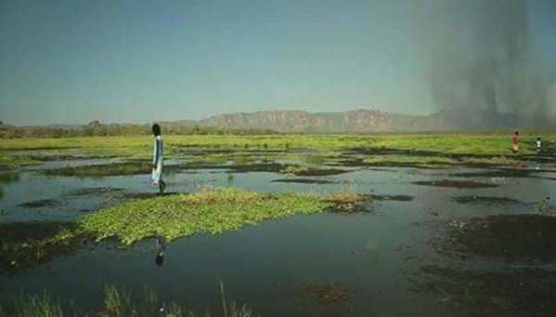

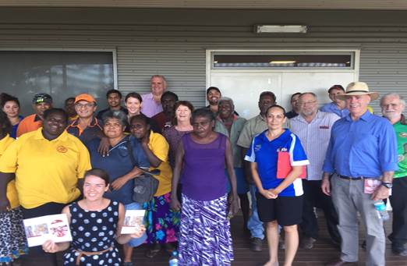

The CLE team, with the assistance of a NT Law Society Public Purposes Trust grant, has developed an exciting cross-cultural resource, comprising a cultural handbook and film series focused on the community of Gunbalanya, titled “Karriyolyolme Konda Kunred – Talking About this Country Gunbalanya

The Project draws upon the voices of the local community leaders and the Traditional Owners to provide an introduction to the people, place and culture of the Gunbalanya region. The project involved extensive community consultation and enabled a two-way learning exchange in which community members, including leaders and elders, were able to outline the best way for service providers and non-Indigenous people to engage with the community, while also explaining important aspects of Kunwinjku culture.

Local community members have identified that this resource, along with acting as an excellent cultural introduction to Gunbalanya for Balanda people, has the potential to be used as a record of culture for future generations and a resource for teaching their culture to children. Participants wanted to show the film to their family members, and one person suggested that it could be aired on NITV.

Just wanted to share a photo from the Gunbalanya Cross Cultural Resource launch yesterday. There was excitement in community yesterday as NAAJA rolled out the red carpet and launched the Gunbalanya Community Cultural DVD and Handbook at the school as part of the West Arnhem College culture week.

Approximately 30 VIPS attended special screening of the main film including Gunbalanya's traditional owners and community leaders. Even the Hon Warren Snowden MP dropped by and attended the launch. Injalak Art Centre has also expressed a desire to screen this film at the launch of their new interactive media space on 10 June 2015.

The overwhelming feedback from the community has been particularly positive and including the following comments:

• Andy Gunaradj, the Indigenous Liaison Officer from West Arnhem regional Council, observed “It is a privilege for people to know (the stories from elders)” and “Important for our elders to be honest and empowered to continue to talk and show our kids for future generations.”

• Connie Nyangul from the Manilakarr Clan group and a traditional owner of the nearby Mikkinj Valley (East Alligator River area) said “People need to watch the movie so they know about Gunbalanya and our country”.

• Kylene Nalorlman said “Fantastic. Good for kids to learn because old people have died and our stories can continue