**Night Patrollers, School Attendance Offices & Community Leaders collaborating to address cyberbullying, youth offending and school attendance**

In almost all our target communities, community elders and local services have indicated that cyberbullying amongst young people is a rapidly growing problem. In parallel to this, there are growing reports that young people are also staying out in the streets later at night. There is a concern that the interconnectedness that telecommunications bring also encourages young people to arrange more night time activities and rendezvous. In Ngukurr, we assisted the Night Patrol and the women’s safe house to call and facilitate a meeting with the school to raise these issues. We helped the Night Patrol and School Attendance Officers in Ngukurr adopt the school attendance protocol we developed in Maningrida of notifying the families and the SAOs the following day should any school age children refuse lifts home and remain out after 10pm. We have also conducted significant CLE on cyberbullying across a range of communities.

**CASE STUDY 1: Responding To Cyberbullying**

During the October trip to Lajamanu we co-presented with the NAAJA civil lawyers at the school and provided CLE on cyberbullying with the senior girls, and, breaking in and joint criminal enterprise with the senior boys. These sessions were highly successful, with all participants engaged through adopting a problem solving framework to the situations presented. Students worked with one of the presenters acting as their ‘friends’ to advise them how to navigate and diffuse the cyber fight created in the scenario. There were some very useful suggestions of engaging family and elders to conduct mediation of larger problems and ignoring or going to the teachers for low level bullying. (See photo and feedback below).

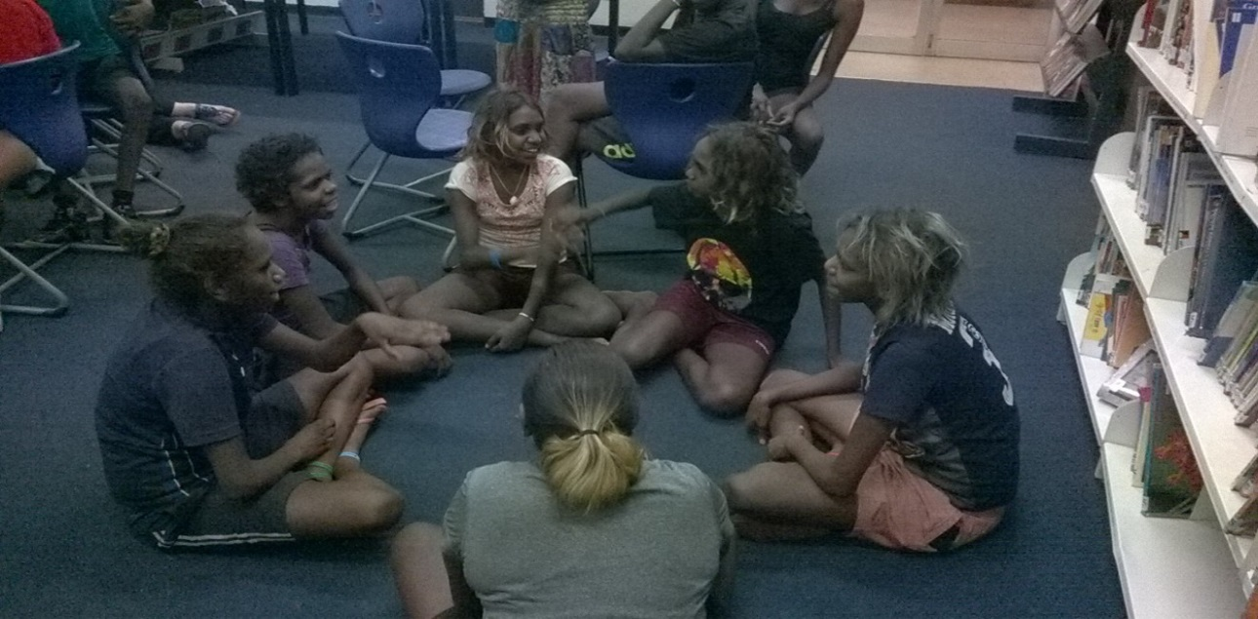

Figure 1: A group of 'friends' planning how to advise presenter to respond to a cyberbullying

**Feedback from Lajamanu School teacher on our Cyberbullying sessions with senior girls (co-presented with NAAJA civil section)**

**Overall comments:**

“Students enjoyed the workshop. Working in small groups with different scenarios worked really well. Scenarios were simple and relative to the student’s lives which helped them understand and relate to it.” “The topic of jealousy was clearly covered, and laws around certain areas were kept simple and clear for a better understanding”

**How was the session pitched/understood?**

“Clear, simple language and repetition helped to ensure the girls understood the key learning areas.”

**Were the key messages appropriate?**

“Students were able to contribute a lot to the discussions and activities as they found the topics relevant. They were age appropriate. As the girls were familiar with the scenarios discussed in the workshop, they were able to identify the issues surrounding jealousy in relationships and potential problems. Following the learning activities, the girls were able to find ways of effectively dealing with these difficult situations.”

**Was it Effective?**

“All students were able to identify a calm and reasonable way of dealing with relationships that experience jealousy/fighting. Not as much content on sexting was covered (as prescribed) but working with the crowd who were a little younger than originally planned, the focus shifted to fighting and the effects of jealousy. These were suitably tailored to fit the cohort.”

**How was the Methodology?**

“Forum theatre and role play activities worked well. Small groups were less intimidating for the girls and they were able to work with a teacher, Warlpiri teacher’s aide or NAAJA representative. Small groups ensures students get the chance to ask questions with less hesitation as being in front of a whole group can be intimidating. Great way to ensure each girl was able to understand and be part of the conversation.”

**Any other comments?**

“Great to have enough people to work with smaller groups. One on one provides a less intimidating learning space. And getting to know you warm up activity worked well as an ice breaker. “

**CASE STUDY 2: Collaboration between NP, Police and School attendance Officer on Child Protection and School attendance**

In Wurrumiyanga, NAAJA ran child protection training with the school attendance officers, which complemented the training delivered to NP. Both of the teams have the same aim of improving the welfare of children, including ensuring the children’s safety or attendance at school.

As a consequence of this training a protocol was adopted, that NAAJA had helped develop in Maningrida, where Night patrol workers note down the names of all the youth that are wandering the streets at night and pass on the list to the School Attendance Officers the next morning, who then follow up as to whether the children attended school the next day. The school attendance officers are uniquely placed to note child protection concerns, and to also make referrals to the civil lawyers at NAAJA to provide families with legal support.

**CASE STUDY 3: Clontarf Legal Education and Careers Day**

In August, NAAJA hosted a legal education, training and careers day for over 45 students from Clontarf Foundations from Casuarina Secondary College, Kormilda College and Palmerston Secondary College. The Northern Territory Supreme Court kindly offered four court rooms as the venue.

The program commenced with some inspirational speeches from the acting Chief Justice of the NT Supreme Court, Stephen Southwood, Priscilla Collins, the NAAJA CEO and Natasha O’Connell an indigenous policy lawyer from NAAJA.

The students then separated into groups to attend the four sessions: “Vocational Speed Dating”, “Environment and the Law” with the Environment Defenders Office and the Kakadu Rangers, “Cyber safety and the Law” with school-based police officer Nicollette Krapapas, and a “You be the Judge” mock sentencing exercise, where students acted out the roles in a sentencing hearing and then were asked to hand down a sentence.

This was a particularly successful event both in terms of numbers of attendees and the exposure students were given to legal and vocational contacts. This is the second time we have organised this event and we received very positive feedback from students.

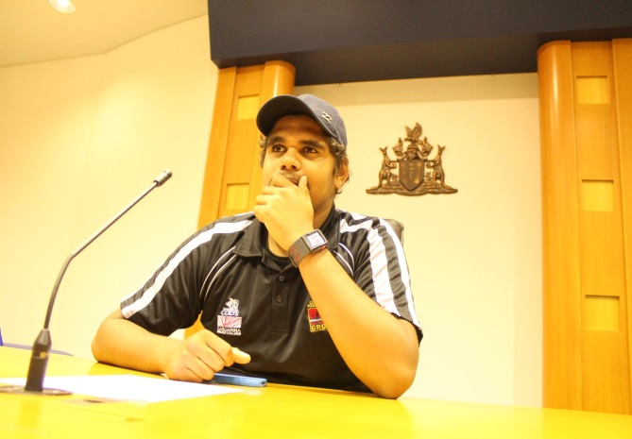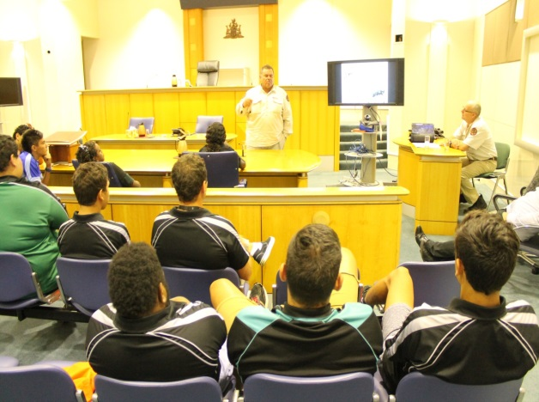Figure 2 , above left: Clontarf student, Alan Mummery, deliberates on the sentence during the ‘You be the Judge’ activity. Figure 3, above right: Gary Lindner explaining his work with Kakadu Rangers to enthralled Clontarf students.

**Responding to requests for domestic violence and sexual assault education through trauma informed practice**

NAAJA is conscious that some of the legal education we are asked to deliver covers topics including child protection and physical and sexual abuse, and accordingly has the potential to re-traumatize vulnerable people.

**CASE STUDY 1: Consultations on sexual assault legal education in community**

The police, clinic and school have reported Maningrida has had an unfortunate history of sexual offending involving juveniles on other juveniles. The CLE team has received requests in Maningrida for delivery of CLE on sexual assault and consent. We have delivered training at the school in conjunction with the school counsellor.

In order to ensure delivery of this information in a safe and culturally appropriate manner, with community support, we have commenced consultations with community members and service providers. Thus far we have undertaken consultations with one of the female traditional owners (who is also the supervisor of the assistant school teachers), a male community leader (who is also the Indigenous Engagement Officer and a member of Bunawarra, a law and justice/mediation group), and some of the women working at Babbarra Women’s Centre. We have additionally consulted with the RAFC workers, the vice-principal and counsellor at the school and MosPlus.

The response has been that providing legal education on sexual assault and consent is a priority, but that it must be co-delivered with and supported by community members, it must be culturally sensitive to ensure its relevance, and must be delivered in a safe environment to minimise the risk of re-traumatisation.

The consultations have enabled the CLE team to identify community safety concerns (such as underage relationships and pregnancies, and youth on youth assaults) and work with the community to address those issues. The process of consultation itself provides an opportunity for participatory action research on community views on appropriate and respectful relationships and informal dissemination of legal information. These consultations are ongoing, with the view to co-develop a lesson plan that can be used in a range of remote communities by the middle of the year.

**Resource Development in Communities**

**CASE Study 1: Gunbalanya Cross-cultural Communication Film**

Funded by a NT Law Society grant, we employed a film maker to work alongside NAAJA, community leaders and an expert anthropologist/linguist to create two 30 minute films and a handbook to promote cross-cultural awareness and communication. The elders commented that not only will the film foster greater respect of local culture and self-respect amongst younger people, but also that this resource can help mutual understanding and communication between ‘Balanda’ (white) and local ‘Bininj’ people.

We see this as beneficial to community safety because good communication can prevent the misunderstandings that can lead to breaches of court orders, tensions in the community and lack of cooperation and trust between local people and service providers. The film works with local elders to seek guidance on best practice in cross-cultural communication and it is hoped will lead to better inter-racial understanding, harmony and trust. The film is available for viewing at <https://vimeo.com/107215776> password: film and will be launched in May 2015 in Gunbalanya.

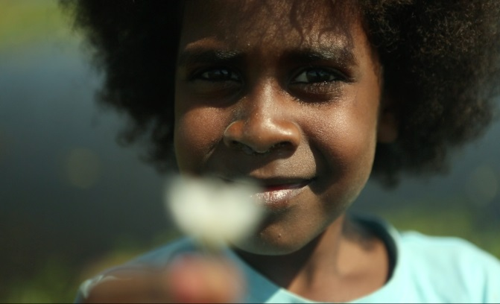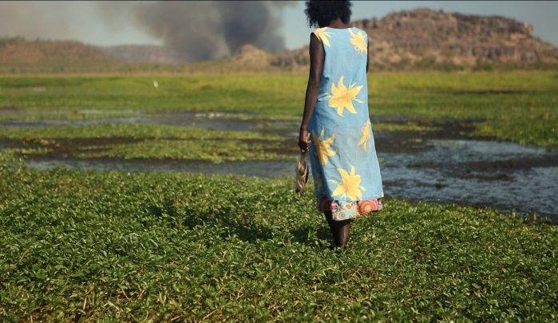

Figure 4 Screenshots from the Gunbalanya Cross-cultural film and handbook

**CASE STUDY 2: Ngukurr Posters and Shield against Family Violence**

In another collaborative project, NAAJA in partnership with the Ngukurr women’s safe house and the Department of Children and Families (‘DCF’) has completed a series of 3 posters explaining the 3 main types of Domestic Violence Orders (‘DVOs’). The concept, wording and sketches were developed in workshops NAAJA conducted over a 12 month period, and the posters use the shield as a metaphor for the protection that DVOs provide.

The posters are soon to be launched and will be given to all women’s safe houses and Night Patrols in the Northern Territory. The Ngukurr women’s safe house will be delivering the training to the Ngukurr NPs in our March trip with the view to the Night Patrols then being trained to use these posters, the plain English scrips and role plays to help explain DVOs to both men and women in the community. We acknowledge and thank DCF which funded the art work, printing and the charter costs for this project.

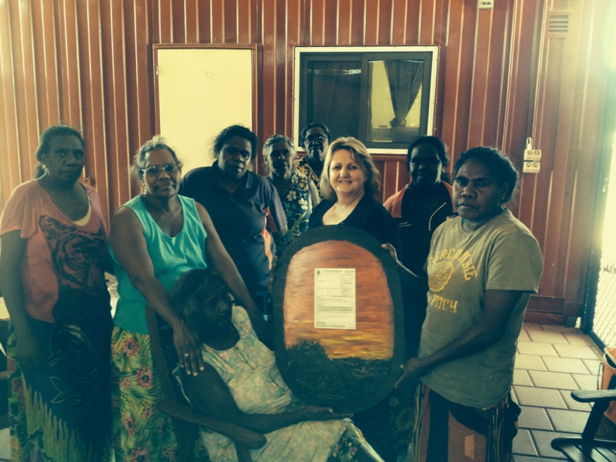  
Figure 5 Ngukurr women’s safehouse and RAFC workers with the recently created ‘DVO shield’

**CASE STUDY 3: CLE Interview on TEABBA Radio about the Importance of Attending Court**

The NAAJA CLE team facilitated a radio interview with George Pascoe (the pastor and senior member of Bunawarra) and the CLE team through TEABBA, on the importance of understanding the criminal justice system, with particular emphasis on the necessity of attending court. This was an opportunity for a community leader to disseminate legal information to increase understanding of and participation in the criminal justice system.

**CASE STUDY 4: “CLE Basics Pack”**

As part of our “CLE Basics and Methodology for the Sector “session, we created a special CLE methodology lesson plan and also created a “CLE Basics Pack” incorporating key articles and examples of our best materials in key areas. We delivered copies of this pack to all the legal services in Katherine and met to discuss how it could be used.

We also developed a practical 2 page plain English guide to “Writing Character Reference Letters for Court” for support people who have family or clients facing court matters. We intend to give copies to all our criminal lawyers to pass on to clients and distribute through our NPs and other contacts in communities. We hope this will encourage people to write or get assistance to write letters for family facing court. Sadly, this rarely happens in the NT.

**NAAJA’s continued involvement with Law & Justice Groups**

We have continued to facilitate Law and Justice Groups in Wurrumiyanga, Lajamanu and Maningrida. Law and Justice Groups are groups of elders/community leaders who meet with NAAJA to discuss recent offending, the upcoming court lists, and choose cases to write references to give the judge/magistrate more information about the background of the defendant and make recommendations about what punishments and rehabilitation would be culturally effective and who are the right people to scold and discipline the person. In addition to writing references, these groups sometimes conduct offender conferencing where they invite the defendant to attend to explain and apologize for his/her actions and then an appropriate person scolds the defendant in front of the elders. This is a common practice in both Lajamanu and Wurrumiyanga. Involvement in these groups promotes the participants standing in the community, promotes the collaboration with other community leaders on community safety issues and also provides a forum for community to discuss safety issues and remedial initiatives. It should be noted that Lajamanu which has had a Law and Justice Group since the late ‘90s has one of the lowest crime rates in the NT. Violent and dishonesty offending in Lajamanu have fallen by nearly 50% since 1995 while the crime rate across the NT has gone up over the same period.

**CASE STUDY 1: Ponki Reference Writing and Offender Conferencing**

During our July visit to Wurrumiyanga, a notable case the Ponkis considered was that of a young mother (who we cannot be identified for legal reasons) who was being sentenced for seriously injuring another family member. Initially the Ponki Mediators were reluctant to write a reference for an offender because of the seriousness of the offending. However, one elder raised the possibility of bringing the offender to the meeting to address the Ponkis. This was done and a restorative justice session then took place. The group heard the story from the offender, and during the session, the offender broke down and apologised to the group and her family for her behaviour. The young woman had lost access to her child as a result of the incident.

The group then spoke to the young woman. Therisita Purantatamiri, a senior woman from the appropriate skin group, then in language reprimanded and growled at the young lady. Therisita explained that the group was appalled at her behaviour and then listed the qualities that she needed to become a strong woman, mother and role model. The reference written by the Ponkis was genuine in both its condemnation of the behaviours and the compassion it expressed for the whole family, as well as outlining ways for the young woman to address the offending behaviour.

As a result of the above conference, the offender has now been dealt with by both the white/Murantawi Courts and the Tiwi communities. She has also received the direct condemnation and denunciation of her behaviour by her own community. This conference has helped achieve the 5 goals of sentencing: deterrence (general and specific), denunciation, rehabilitation, punishment and public safety. She has had an opportunity to apologise to the community and to her own family. She reported that it has eased the burden and left her in a better position to pursue rehabilitation. The families were also in a better position to support her rehabilitation in light of her contrition.

**Working to improve interagency collaborations in remote communities to pursue community safety**

**CASE STUDY 1: CLE Facilitating Meeting between police and the Bunawarra Dispute Resolution Elders**

In response to concerns raised in open court by police and prosecutors about the legitimacy of Bunawarra as a representative of the community in the reference writing process, the CLE team organized a meeting with the OIC of Police and a NAAJA criminal lawyer.

During the meeting, we confirmed that the reference writing process is collaborative and confirmed that the CLE team’s role is to explain sentencing principles and what the court will find relevant. While it was agreed that the Bunawarra is not representative of the entire community, the CLE team explained that it is impossible for the group to be entirely representative in such a divided community with many different clan groups, and a large population.

The OIC agreed with the CLE team, and also agreed that although there is some negative sentiment towards the group, the community recognises members of the group as holders of knowledge when it comes to ceremonies, boundaries of land, and as facilitators in mediations.

We explained that writing character references is an opportunity for the community to provide the court with the offender’s personal background which might otherwise not be raised, as well as allowing the community to put forward how they would deal with the offending traditionally.

We also raised the significant overlap between NP and Bunawarra, and the NPs involved in the group can apply the knowledge gained from the legal education training that the CLE team provides to the NP team (for example criminal process). The success of the meeting with the OIC at addressing the concerns of the police is reflected in the fact that the criminal lawyers have confirmed that concerns about the group’s legitimacy are no longer being raised at court.

**Feedback from the Bunawarra member following NAAJA’s meeting with police**

“Thanks, it’s wonderful to know that the work we do that Police don’t know, the other side of the story is we help countrymen understand Balanda law and ways we can refer them to other services in the community or in Darwin like the … case…  maybe one day we could arrange a meeting with the Police, Bunawarra and your Team to discuss ways and how we can make Maningrida a safe place for all and work together for the same cause….

Many thanks to you and the team, let’s keep up the good work and show that we have a passion for common law and the society.”

**CASE STUDY 2: Collaboration between Night Patrol, Police and Ponki Mediators**

In the July trip to Wurrumiyanga, NAAJA facilitated a meeting between the Police Officer in Charge (‘OIC’) and the Ponkis. The OIC discussed the possibility of low level matters being referred to the Ponkis with the assistance of Kevin Doolan, a member of the Ponki Mediators and also the Youth Diversion officer. This would be an informal referral, as opposed to the formal referrals to Youth Diversion. The OIC agreed to talk to Bill Toy the NP manager, and the need to include Night Patrol, and the school attendance officers.

**CASE STUDY 3: Co-presenting with the Women’s Safe House to the FAFT and Child Care Centre in Kalkarindji**

In our October trip we ran a session on Domestic Violence Orders with the Women’s Safe House in Kalkarindji and then planned and co-presented a session with the Women’s Safe house Workers to the Families as First Teachers (‘FAFT’) and child care centre’s Playgroup young mothers. See feedback and outcome below.

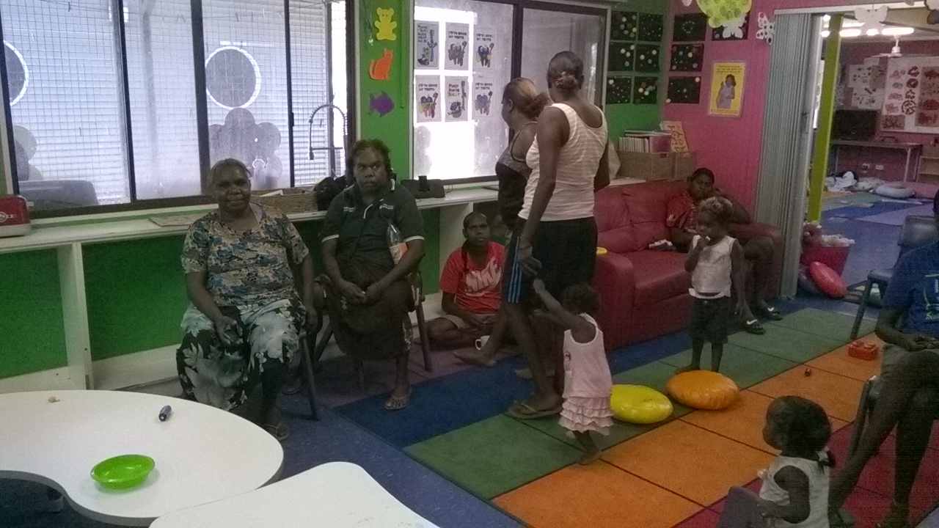

**Figure 6 WSH workers prepare for session with FAFT young mothers**

**Feedback from the FAFT coordinator on DVO session with WSH and FAFT**

The session was a great success and we received the following email from the FAFT coordinator one week later illustrating the benefits of the session:

“I am just writing to you with a good news story after your recent visit to the Kalkarindji Playgroup on the 28/10.

The day after your visit I had one young mother come to me and share a brave story. She explained that she was having a fight with her partner on the evening of the 28th and explained to him that she had rights, he isn’t allowed to lay a hand on her, etc. She said that she frightened him with her newly learnt knowledge, so much that he got in his car and drove to Katherine for a few nights to calm down.

The young mother was really appreciative of the things that you spoke about and she wanted me to let you know that you really helped her in that situation.

It is so important to educators and empower these women, and to hear success stories like that is a massive win”

**CASE STUDY 4: Night Patrol Collaboration with Police to Respond to DV and Alcohol/Grog Running**

During the October training with the Kalkarindji Night Patrol the key issues that emerged were: Night Patrol’s powers when responding to DV and NPs response to people in possession of alcohol. Although NP do not have specific powers to seize alcohol, we workshopped with the NP and the local police a protocol for NPs in these circumstances.

**Responding to alcohol in the community**

This protocol involves NP encountering people with alcohol in the community giving these people 4 options:

1. To tip the alcohol out;
2. To return to the drinking spot to complete their drinking:
3. To surrender the alcohol to the NPs, to take to the police for seizure and destruction; or
4. NP will call/notify police and be witnesses in any action against drinker.

**Responding to low and high level Domestic Violence**

How to break up Fighting particularly if low level DV

* Ask family to help
* Speak calmly
* Suggest woman go to safehouse with NP and that man go to other family (NP to assist woman first)
* Suggest that parties can talk about it tomorrow after having a good sleep at safehouse and at other family
* Remind people that if they fight/cause trouble with they will be banned from the club for 3 months by NP
* If there is an injury take the victim to the clinic/call for assistance straight away
* If safe and if necessary, may intervene to separate pair by using the right to use moderate force in defence of another.
* If high level DV where there is a risk of serious injury then obliged to call police immediately

As a result of training, NPs are better equipped to collaborate with police and respond to DV and the illegal smuggling of alcohol into the community and comply with mandatory reporting of violence. We have subsequently shared these protocols with NPs in Lajamanu. This has provided a useful example for other communities to follow while still acknowledging the limitations of powers.